**CS551 ADVANCED SOFTWARE ENGINEERING**

**MIDTERM HACKATHON (TAKE HOME PROGRAMMING)**

**Name:** Prathyusha Dinne **Student ID:** 16161128

**1)**

**GitHub Link:**

[**https://github.com/pdrk2/Midterm**](https://github.com/pdrk2/Midterm)

**Design:**

One user creates a route using scribble maps API and enters the details of route, check in points into the database. Details include description, image, map and title options. The user who would like to walk through the route has the option to choose any one of the different available routes. Upon clicking one route, all the details were displayed and a start symbol displayed to begin his journey. Upon clicking the start button, the next check in point for the user to reach will be displayed along with the respective details. The user will also have the option to walk through the check in point from his location by getting directions from Google map. The user also has the option to share his/her route on social networks. Upon clicking the check in button in this page, the next check in point will be displayed along with their details and directions from user’s location. Once destination is reached, user will be given an message that he/she has reached their destination point.

**Class Diagram:**

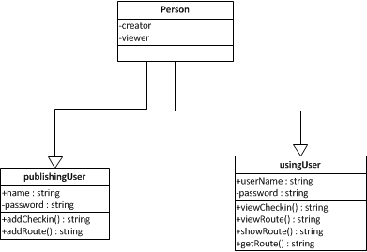

Above class diagram has two users, one who publishes the route and the other user is the one who uses the route in the app. Each user is given a login name and password to use the services in the app. The publishing user has the right to add routes and check points to respective routes. The using User has the option to view the routes, check in’s and walk through the routes as per the directions.

2)

**Features Implemented:**

1. **Existing web Services/APIs:**

* **Scribble Maps API:**

The Scribble Maps API is a cross browser, cross API, mobile ready, HTML5/JavaScript, interactive map builder and authoring platform. This API allows you integrate all the features and power of Scribble Maps directly into the web based app. On the back end we store the map data and allow you to quickly convert from one to format another. The Scribble Maps API was built from the ground up using native technologies so the editor can run in both a mobile and desktop environment.

* **Facebook API:**

This API is the core of Face book Platform, enabling developers to read from and write data into Face book. This API presents a simple, consistent view of the Face book social graph, uniformly representing objects in the graph (e.g., people, photos, events, and pages) and the connections between them (e.g., friend relationships, shared content, and photo tags).

* **Twitter API:**

This API allows users to tweet, share, and chat with different kind of persons all over the world. This API provides us with various options in order to make our simple and easy.

* **Google Map API:**

This is very important API that is used in every web or mobile application. Using this app we can find the place or city. Also we get directions from one place to different place with the help different kind of views.

* **Image slider Option:**

I have included the option of sliding multiple images on a web page for an effective user interface design. I have used slider option to implement this.

1. **Database:**

I have used a local database in order to insert, update and retrieve the values from various sources. I have totally created two tables, one is route table to store the route details like name, description, image url, map url and price. The other table is check in table which is used to store details of each check-in corresponding to the respective route. The check-in details include title, description, latitude, longitude and image of the check-in point. Below screenshots are route and check-in tables.

**Route Table:**

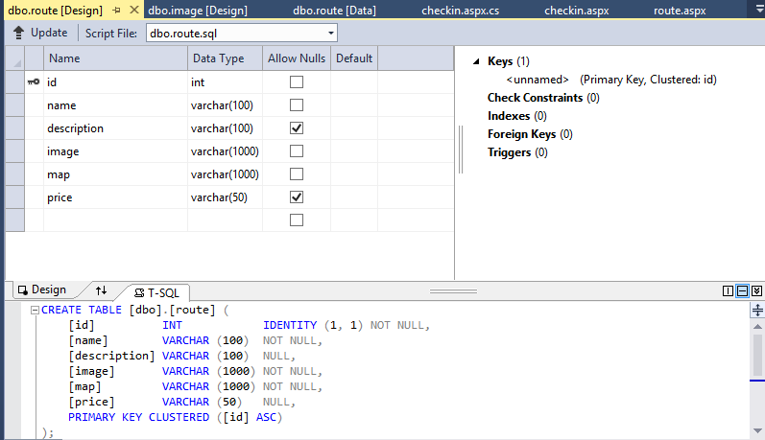

**Check-In Table:**

Here route name is used as foreign key which joins both route and check in tables.

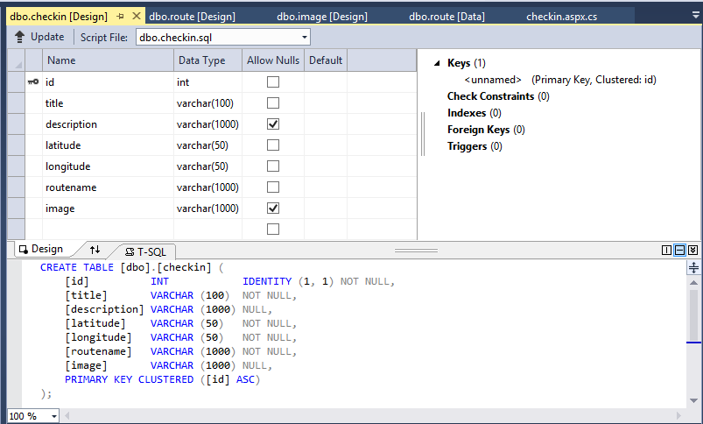

3)

**Screenshots of all features:**

**Home Page:**

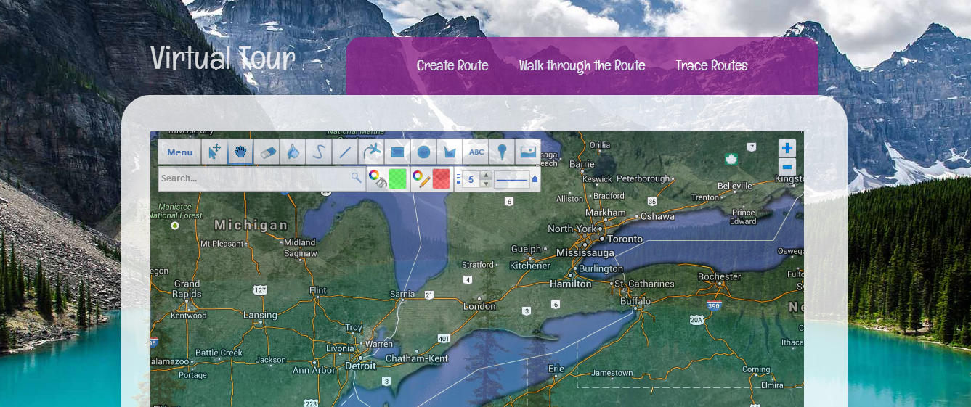

**Publishing User will create the route using scribble maps options:**

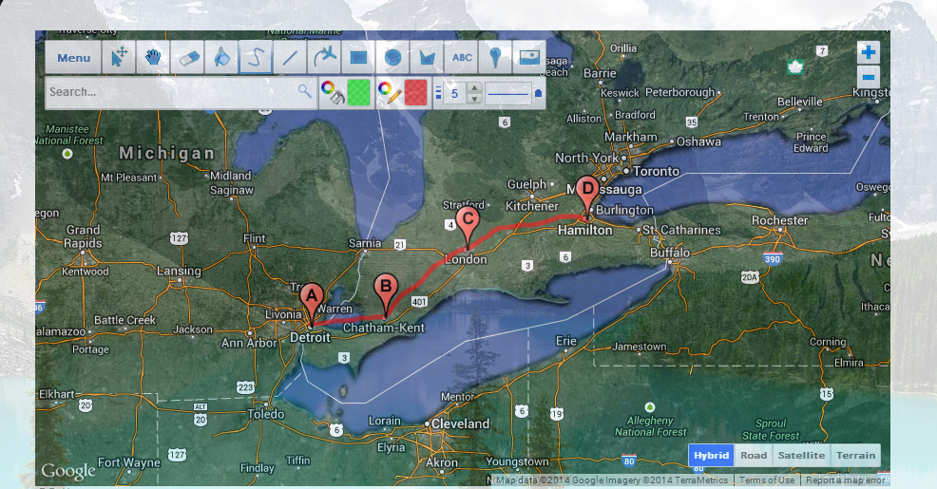

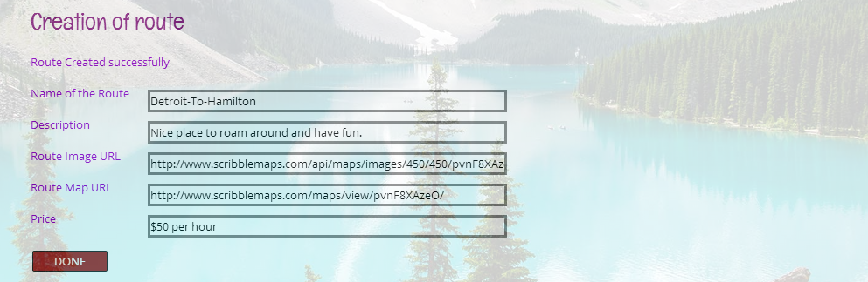

**Check-in Point was created by providing details like title, description and inserting image:**

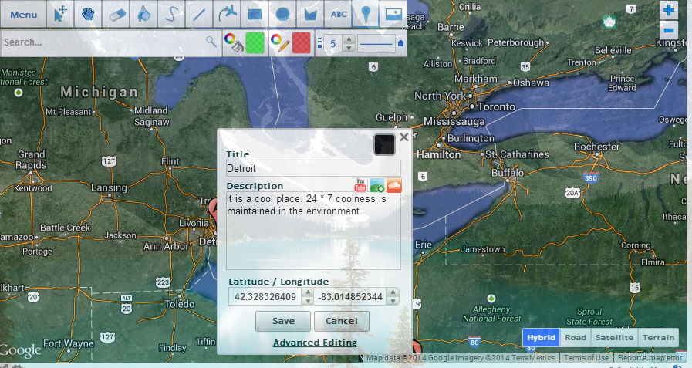

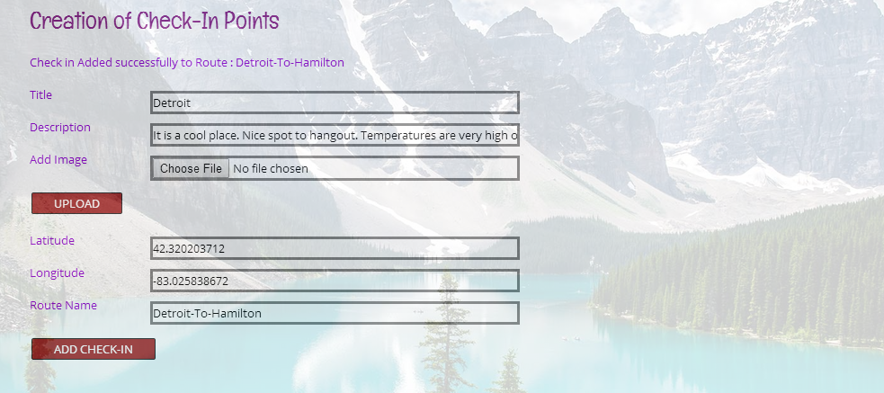

**Other user using this app will be provided with a list of routes to choose:**

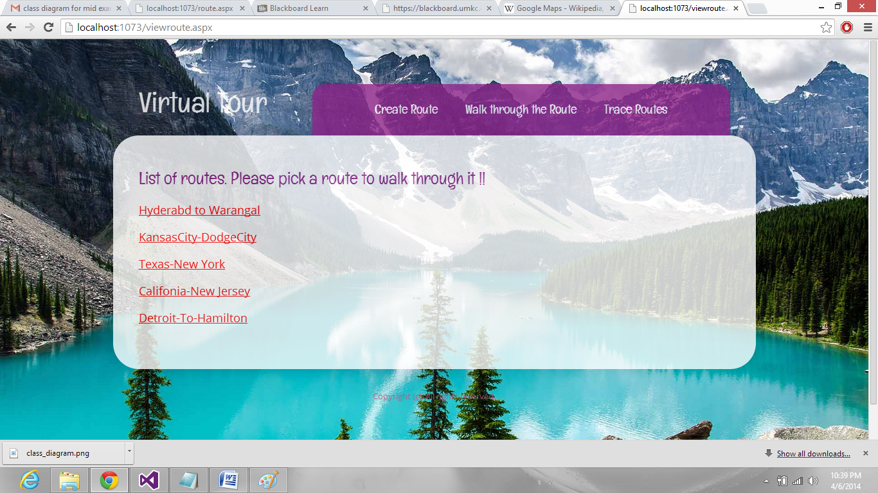

**Upon selecting one of the route, its details will be provided:**

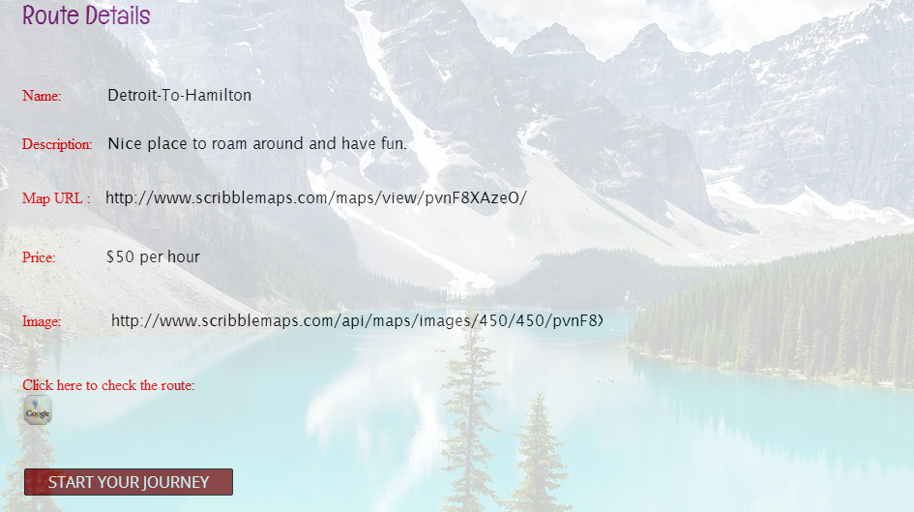

**Upon clicking the google map icon we get the route:**

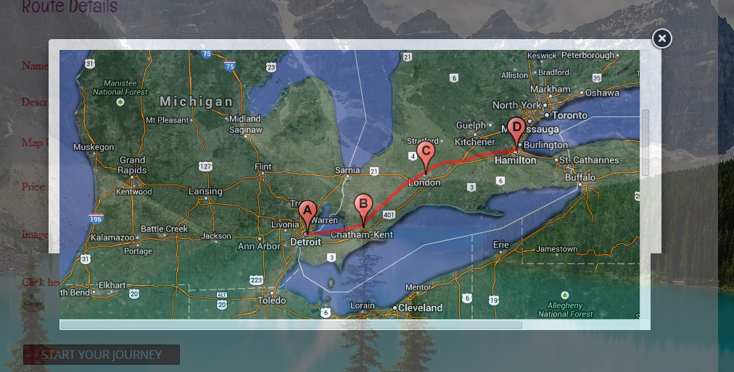

**Upon Clicking the “Start” the journey starts and the map of the first check in point along with the directions from the user location were displayed.**

Upon clicking the “Get my position” link, user’s location will be displayed in From and the first check in point details will be displayed in To. So, upon clicking “submit” button the map along with directions from user location to first check in point will be shown. The images uploaded from desktop for each check in point will be displayed right side under tour images section.

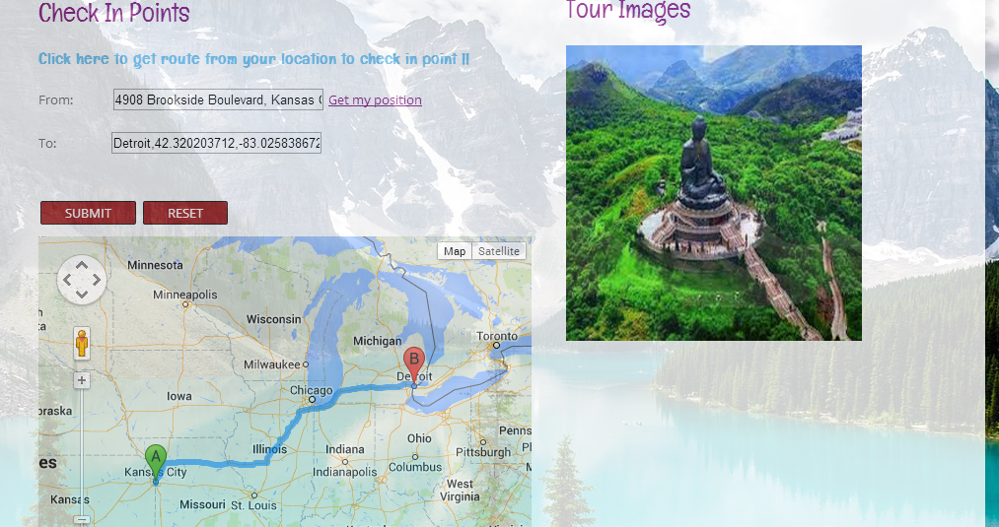

**The details of first check in point will be displayed along with providing the option of sharing his/her route on facebook:**

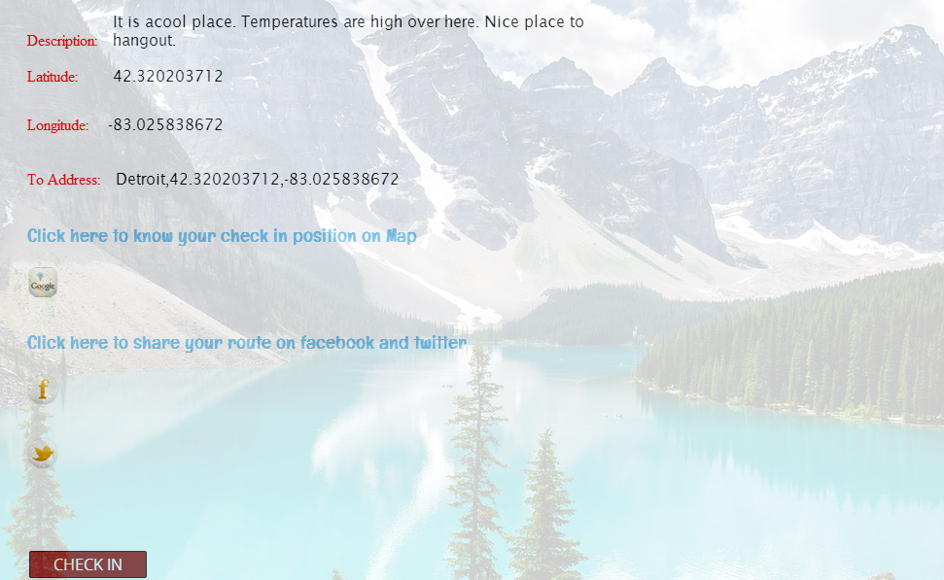

**Upon clicking the facebook icon, the user’s route will be shared on facebook:**

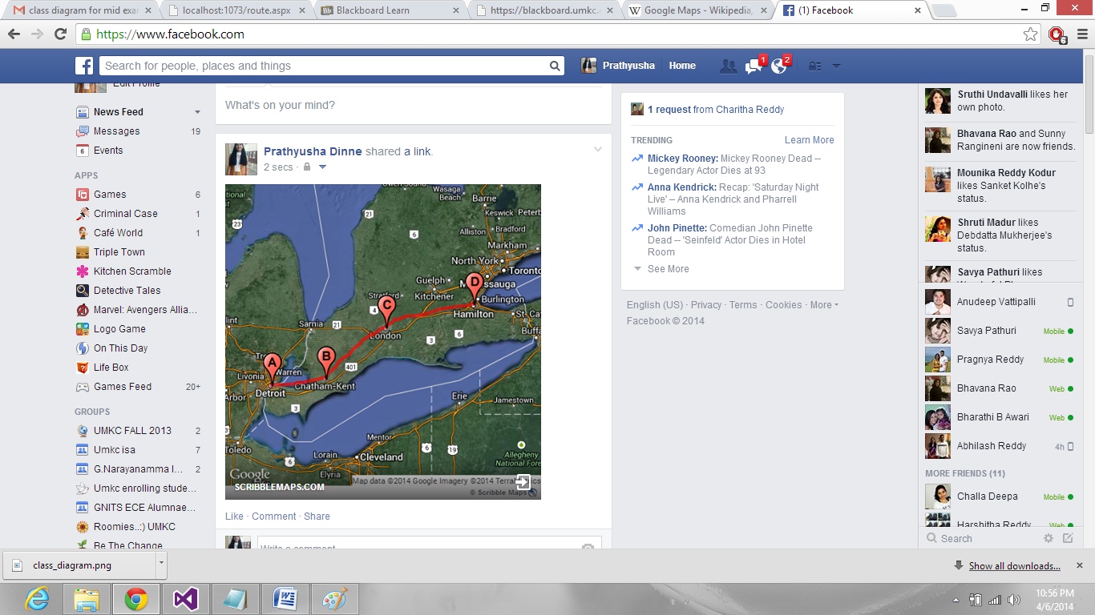

**Route shared on twitter too:**

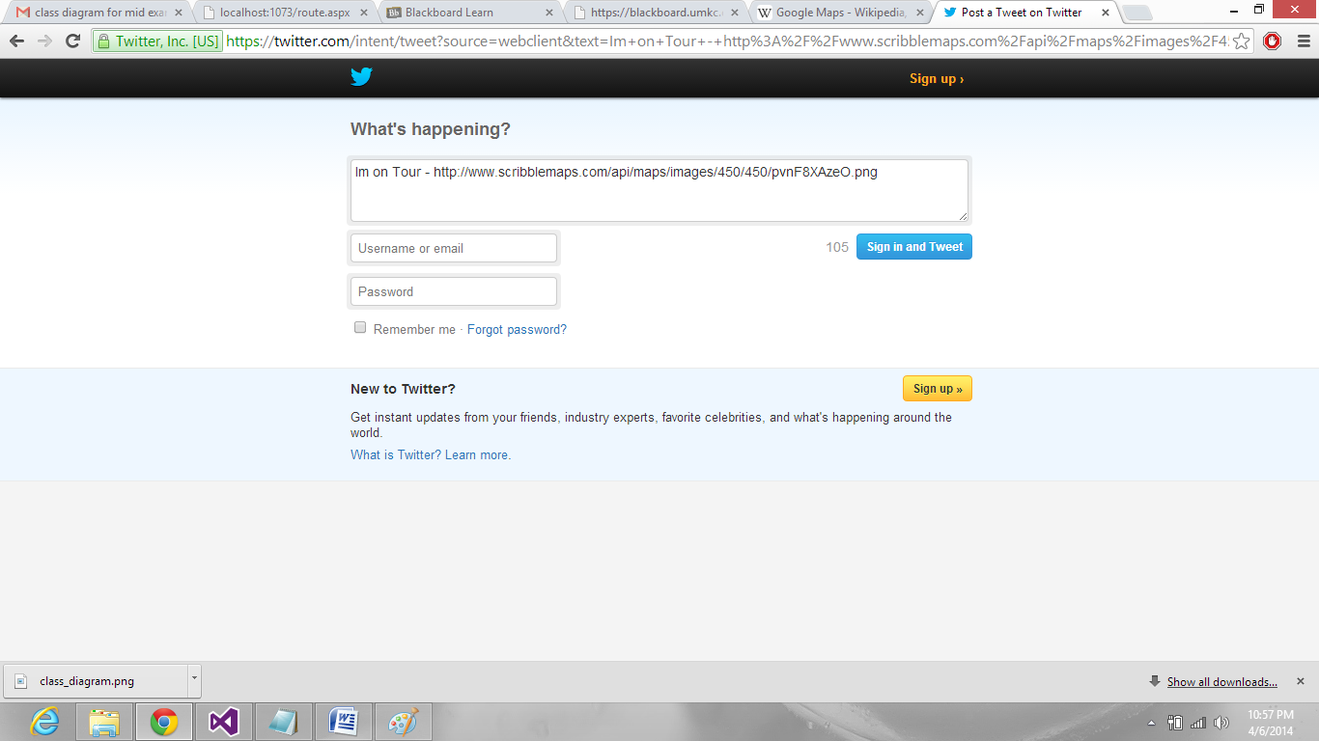

**After reaching first –point, user clicks on check in so that the next check in point map will be displayed, along with directions from first check point point:**

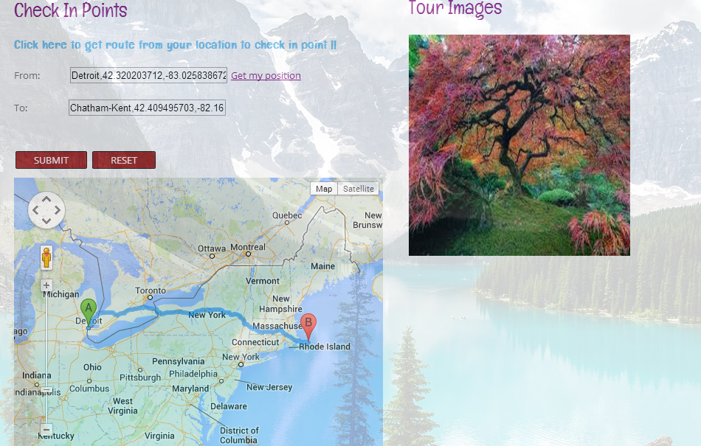

**After walking through all the check pints, when user reaches the destination, below message will be displayed indicating that “User have completed walking through the route and reached the destination point”**

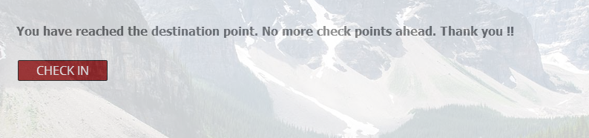

**4)**

**Website URL:**

[**http://localhost:1073/route.aspx**](http://localhost:1073/route.aspx)

[**http://localhost:1073/viewroute.aspx**](http://localhost:1073/viewroute.aspx)

[**http://localhost:1073/displayroute.aspx**](http://localhost:1073/displayroute.aspx)

[**http://localhost:1073/checkin.aspx**](http://localhost:1073/checkin.aspx)

**Webservice URL:**

[**http://localhost:14575/login.asmx**](http://localhost:14575/login.asmx)

**5)**

**References:**

[**www.stackoverflow.com**](http://www.stackoverflow.com)

[**www.scribblemaps.com**](http://www.scribblemaps.com)

[**www.google.maps.com**](http://www.google.maps.com)

[**www.foursquare.developers.com**](http://www.foursquare.developers.com)

[**www.google.com**](http://www.google.com)

[**www.forums.asp.net.com**](http://www.forums.asp.net.com)**,** [**www.w3schools.com**](http://www.w3schools.com)